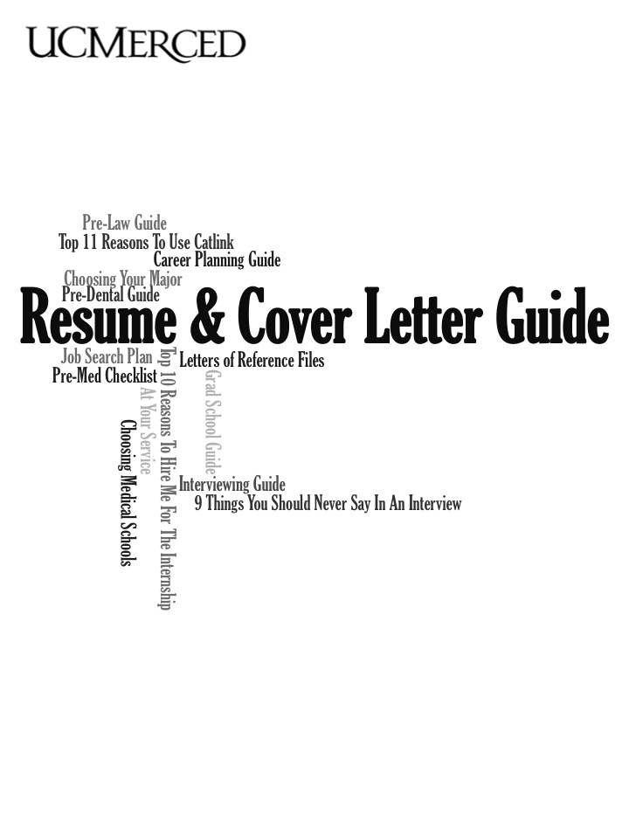

Welcome!

You have less than a minute to make a strong lasting impression on a hiring manager, and that initial step begins with a resume and cover letter. The Center for Career & Professional Advancement’s primary goal with this Resume and Cover Letter Guide packet is to help you with the job application process. This packet serves as an outline for resumes and cover letters, but it is possible to break the rules that are outlined in here.

For more help with your resume or cover letter, stop by the Center for Career & Professional Advancement and make an appointment with one of our professional staff members. You can also have your resume peer reviewed by a student career consultant through email, by appointment, or at drop-in hours.

Center for Career & Professional Advancement
Monday – Friday, 8:00am – 5:00pm
Kolligian Library, Suite 127
(209) 228 -7272
careercenter@ucmerced.edu
www.careercenter.ucmerced.edu

Resume Do’s and Don’ts

DO:
- Keep your resume to one page
- Begin phrases with action verbs such as “developed, “mentored,” and “assisted”
- Include your contact information: address, phone number, and professional email
- Include work locations and dates. Ensure dates are in reverse chronological order
- When using an objective statement include specifics about position and skills required
- Check your resume before submission or have a Career Center professional review it for you
DON’T:
- Include your references in your resume
- Include your high school information unless you are a first-year or sophomore
- Use hard to read fonts or sizes for your resume
- Use different formatting. Keep bullet points, underlining, placement of dates, etc. consistent throughout the resume

VERB LIST FOR RESUMES & COVER LETTERS

Management Skills
Administered
Analyzed
Assigned
Attained
Chaired
Consolidated
Contracted
Coordinated
Delegated
Developed
Directed
Evaluated
Executed
Improved
Increased
Organized
Oversaw
Planned
Prioritized
Produced
Recommended
Reviewed
Scheduled
Strengthened
Supervised
Communication Skills
Addressed
Arbitrated
Arranged
Authored
Collaborated
Convinced
Corresponded
Developed
Directed
Drafted
Edited
Enlisted
Formulated
Influenced
Interpreted
Lectured
Mediated
Moderated
Negotiated
Persuaded
Promoted
Publicized
Reconciled
Recruited
Spoke
Translated
Wrote
Research Skills
Clarified
Collected
Critiqued
Diagnosed
Evaluated
Examined
Extracted
Identified
Inspected
Interpreted
Interviewed
Investigated
Organized
Reviewed
Summarized
Surveyed
Systematized
Technical Skills
Assembled
Built
Calculated
Computed
Designed
Devised
Engineered
Fabricated
Maintained
Operated
Overhauled
Programmed
Remodeled
Repaired
Solved
Upgraded
Teaching Skills
Adapted
Advised
Clarified
Coached
Communicated
Coordinated
Demystified
Developed
Enabled
Encouraged
Evaluated
Explained
Facilitated
Guided
Informed
Instructed
Persuaded
Set goals
Stimulated
Trained
Financial Skills
Administered
Allocated
Analyzed
Appraised
Audited
Balanced
Budgeted
Calculated
Computed
Developed
Forecasted
Managed
Marketed
Planned
Projected
Researched
Creative Skills
Acted
Conceptualized
Created
Customized
Designed
Developed
Directed
Established
Fashioned
Founded
Illustrated
Initiated
Instituted
Integrated
Introduced
Invented
Originated
Performed
Planned
Revitalized
Shaped
Helping Skills
Assessed
Assisted
Clarified
Coached
Counseled
Demonstrated
Diagnosed
Educated
Expedited
Facilitated
Familiarized
Guided
Motivated
Referred
Rehabilitated
Represented
Clerical/Detail Skills
Approved
Arranged
Catalogued
Classified
Collected
Compiled
Dispatched
Executed
Generated
Implemented
Inspected
Monitored
Operated
Organized
Prepared
Processed
Purchased
Recorded
Retrieved
Screened
Specified
Systematized
Tabulated
Validated
More Verbs for Accomplishments
Achieved
Expanded
Improved
Pioneered
Reduced (losses)
Resolved
Restored
Spearheaded

Sending Resume and Cover Letter Electronically

Sending resume/cover letter as an attachment:
- Use a professional email address such as your UC Merced email
- Attach your resume/cover letter as a Microsoft Word or a PDF document
- Include your first and last name in the filename when attaching a file
- Make your subject line informative, example: “Jon Wood’s Research Analyst Resume”
- Include your name, position applying for, and contact information in the email
- Use spell check for any grammatical errors

Sending resume/cover letter in the body of an e-mail message:
- Include your name and the position you are applying for in the subject line
- Include a brief introduction about yourself in the email
- Below your introduction, paste or write your cover letter
- Add your resume a couple of spaces below the cover letter
- Align all the text to the left margin
- Don’t use bold, underlining, bullets, different fonts, colored text, or html codes
- When leaving a signature make sure it is written and not a signature font

Scanning your resume/cover letter:
Some large employers and companies use resume database tracking systems. They scan incoming documents (resumes and cover letters) into their database and when they have openings for positions, they are able to retrieve resumes and cover letters relevant to keywords. Companies will often indicate on their website if they utilize this technique.

Management Resume Example

Lily Wilson
1234 Brookdale Road
Merced, CA 95343
209- 444- 8888
lwilson2@ucmerced.edu
OBJECTIVE:
Seeking the assistant marketing position at the 2248 Modesto Apple retail store

EDUCATION:
University of California, Merced Merced, CA
Bachelors of Science, Management Expected Graduation May 2016

PROFESSIONAL EXPERIENCE:
UC Merced, Office of Student Life Merced, CA
Office Assistant Student Intern August 2013- Present
- Assisted up to 30 people a day with questions, appointments, or room reservations
- Responsible for properly checking out the department’s high value media equipment to all clubs and organizations for marketing and events
- Organized the department’s mail and paperwork

Toyota Los Angeles, CA
Product Marketing Intern May 2013 – August 2013
- Created two advertisement campaigns for the 2012 Hybrid
- Assisted in the development of five marketing advertisements for the 2012 annual summer specials for Hybrid, Lexus, Scion, Camry, and Corolla using Photo Editor
- Increased media traffic by 35% on Facebook, and gained 150 more followers on Twitter

LEADERSHIP EXPERIENCE:
Delta Zeta Alpha Merced, CA Vice President of Public Relations August 2013 – Present
- Directed monthly team meetings and supervised 10 officers
- Planned two fundraising events to help raise supplies for blind organizations
- Executed marketing strategies via social media and community outreach

SKILLS:
- Proficient in Microsoft Word, Excel, and PowerPoint
- Familiar with Photoshop, FotoFlexer, Photo Editor, and Adobe Illustrator
- Knowledgeable in oral and written Spanish and Mandarin Chinese

HONORS AND AWARDS:
Chancellor’s List, 2012– 2013
Social Sciences, Humanities, & Arts Resume Example

Sarah Johnson
760 Grandview Merced, CA 95340
(555) 277-0544
sjohnson14@ucmerced.edu

EDUCATION
University of California, Merced Expected Graduation Spring 2017
Bachelors of Science, Cognitive Science Minor, Psychology

PROFESSIONAL EXPERIENCE
School of Social Sciences, Humanities, and Arts University of California, Merced
Office Assistant August 2014- Present
- Attended to student questions and advisory requests
- Assisted inter-office faculty with projects including meeting independent project deadlines
- Emailed and followed-up with faculty and professors
- Maintained confidentiality with office documents

Best Buy Merced, CA
Cashier May 2014- November 2014
- Worked 20 hours/week while maintaining strong academic record and course load
- Proven ability to answer customers’ questions and give information regarding the business procedures and policies in an exact and customer-friendly way
- In-depth knowledge of handling returns and exchanges of goods
- Accurately balanced cash drawer and receipts

RESEARCH EXPERIENCE
Cognitive Science Laboratory University of California, Merced
Research Assistant Spring 2015- Present
- Supported and worked with faculty on research projects
- Experienced in data entry and analysis requiring responsibility with attention to detail
- Made multiple project deadlines, fulfilled faculty’s’ needs, and completed personal responsibilities
- Upheld confidentiality with research
- Operated sensitive lab equipment

NOTABLE SKILLS
Bilingual and bi-literate in Spanish

Science & Engineering Resume Example

Christy Smith
5200 N. Lake Road, Merced, CA 95343
209.724.4132
csmith@ucmerced.edu

OBJECTIVE
Laboratory research position in biotechnology using critical thinking and teamwork skills

PROFESSIONAL EXPERIENCE

Molecular Biology Lab Student Assistant November 2013-Present
University of California, Merced Merced, CA
- Conducted DNA cloning, sequencing, mapping on protein samples of Escherichia coli bacteria
- Prepared written report summarizing data analysis on Escherichia coli experiments
- Performed PCR and gel electrophoresis experiments on Eubacteria DNA samples

Volunteer June 2013-May 2014
Mercy Medical Center Merced, CA
- Assisted patients in the Emergency Department once a week for three hour shifts
- Helped clean rooms and prepared bedding before and after when patients were discharged
- Foreshadowing nurses and doctors during their time of performing procedures on patients

Assistant Laboratory Technician September 2014-May 2015
University of California Merced Merced, CA
- Maintained proper records and documentations of lab protocols for general chemistry and biology courses
- Participated in monthly trainings regarding department laboratory procedures
- Assisted in conducting experiments alongside professors and teaching assistants

QUALIFICATIONS
Laboratory Abilities: Preparing samples, using light microscope and spectrophotometer
Software: Microsoft Word, Excel, Outlook, and Photoshop
Foreign Language: Mandarin and Spanish

EDUCATION
University of California, Merced Expected Graduation May 2017 University of California Merced Girls Volleyball Team
Bachelors of Science, Biological Sciences Minor: Psychology Emphasis: Human Biology go

ASSOCIATIONS
Delta Epsilon Mu Professional Fraternity, Vice-President
University of California Merced Girls Volleyball Team

Cover Letter Basics

- A cover letter is a personal introduction of yourself to a prospective employer
- Research the company first to fully understand the position you are applying for
- Outline your interest in the position, the company, and why you are a qualified candidate
- Tailor each cover letter to the specific job description that you are applying for
- Emphasize the skills and experiences that you are able to offer to the company

Cover Letter Do’s and Don’ts

DO:
- Briefly demonstrate to the employer that you are familiar with the position’s responsibilities and the employer’s organization
- Personalize the cover letter by relating your desire for the job to your personal experience
- Illustrate your qualifications with examples by providing specific achievements that can aid in the advancement of the company’s agenda
- Send the letter to a specific person using their first and last name along with any professional titles (Doctor, Professor, Mr. or Ms.)
- When in doubt, address the letter to “Dear Hiring Manager:”
- If a specific person alerted you to the job opening, include that person’s name and professional affiliation (i.e. Professor John Dun of UC Merced’s School of Engineering suggested that I should contact you about your Sanitary Engineering Opening)

DON’T:
- Repeat your resume
- Send the same generic cover letter for every job
- Write more than one page
- Use the exact wording in the job description for your skills

Analyze your background: Think about your background in relation to the job responsibilities and qualifications. Ask yourself “What have I done that is similar to this position?” Areas to think about are courses taken, classroom projects, past work, experiences, summer jobs, internships, volunteer experience, and extracurricular involvement.

Cover Letter Format
Your name
Street Address
City, State Zip code

Name of Contact Person
Title
Organization
Street Address
City, State Zip Code

Date

Dear (Name of Contact Person):

Opening Paragraph:

Provide a short introduction about yourself to the reader. Identify what position you are applying for, at what company, and how you learned about this position. Briefly describe why you are interested in this particular position and company.

Body of the Letter:

Describe why you should be considered as a potential candidate for the position. Relate your qualifications to the specific job requirements by using examples from your experiences and achievements. Talk about the skills you have that fit the requirements for the position. This is your chance to give the reader more of an insight of who you are. Don’t repeat your resume in the cover letter, but do include some details.

The Closing Paragraph:

In the final paragraph express your interest for an interview by providing your availability and contact information. Thank the employer for his/her time and consideration.

Sincerely,

Your Signature

Phone number
Email

Cover Letter Sample #1

John Smith
2375 Apple Wood Drive
Merced, CA 95340

Mr. Matthew Hart
Manager
Wells Fargo, Merced
5200 Sherman Road
Merced, CA 95340

March 28, 2012

Dear Mr. Hart,

I discovered a recent job opportunity through the University of California, Merced’s Career Center website, and would like to express my interest for the bank teller position at Wells Fargo. As a third year management major, with three years of dedication to the Business Club as Vice President of Community Outreach, I can assure you that my skills and experiences will help improve your business sales and customer loyalty.

My main interest in being a part of Wells Fargo stems from your company’s impressive reputation. The prestige of the firm is best captured through your company’s value in building strong relationships with their customers. I can relate to Wells Fargo’s value with my personal experience of trying to create new partnerships with local businesses to help improve the Business Club’s connection network for events, workshops, and campus guest speakers. With hard work, determination, and persistence, I was able to solidify 10 new businesses for next year’s events. I believe that with my passion for business and motivation to improve any type of numbers, I can be a valuable asset to your branch.

Thank you for taking the time to consider me as a prospective bank teller for Wells Fargo. I welcome the opportunity for an interview on a time and day that works best for you. If you have any questions regarding my academic or business accomplishments, please feel free to call or email me at any time.

Sincerely,

John Smith

(222) 475 – 5678
jsmith24@ucmerced.edu
Cover Letter Sample #2

Bryan Carter
123 7th St.
Los Angeles, CA 90001

Ms. Barbara Smith
Head of Operations Management
Personal Development
NSF Fabricators Corporations
125 8th St. Los Angeles, CA 90001

21st February 2013

Dear Ms. Smith,

I am writing in response to your advertisement for the Manufacturing Manager position at Foster Farms. I discovered this position when I was reading an advertisement on your company’s website.

I am very interested in the position and as you will be able to see from my resume, I have had an extensive amount of experience in the manufacturing business. Having held my previous job title as Senior Management for five years, I can assure you that I am familiar with the necessary requirements for this line of work. I am an energetic individual who is committed to working well individually as well with collaborative teams for the success of this department. I am confident that I have the skills and attributes that you are seeking for this position.

I would be very interested for the opportunity to arrange a meeting time at your convenience. Please feel free to contact me if you have any further questions. Thank you for your consideration.

Best Regards,

Bryan Carter

(323) 661-4321
gcarter@yahoo.com

References

References:
- References verify the information that is provided in your resume and cover letter
- References will be contacted during the final stages of the job selection process
- Choose people who know you well enough to serve as an advocate to the employer
- References may include former supervisors, professors, teaching assistants, or advisors
- Don’t choose relatives or friends as professional references
- Discussion topics include strengths, weaknesses, communication, leadership, and details of your past experiences

How to use a reference:
- Ask your reference’s permission first before including them in your application
- Provide a copy of your resume to your reference
- Share with your reference the company and position you are applying for
- Stay in contact with your references so they can speak knowledgeably about you

When to use a reference:
- Provide references only if the employer requests it
- Always have at least three references available during your interview or shortly after

Formatting References

Your Name
Current Address, City, State, Zip code
Phone Number
Email Address

References

Full Name
Job Title
Company
Company Address
Phone Number
Email Address
Relationship to Reference

Full Name
Job Title
Company
Company Address
Phone Number
Email Address
Relationship to Reference

Full Name
Job Title
Company
Company Address
Phone Number
Email Address
Relationship to Reference

References Example

Shelly Anderson
1032 R. Street, Merced, CA 95340
209-667-4444
sanderson@ucmerced.edu

References

Deborah Smith
Director of Marketing
ADworks Corporation
2 Sacramento Plaza, Suite 2434
San Francisco, CA 94311
(415) 555-0444
deborah.smith@adworks.com
Previous Employer

Philip Meyer, Ph.D.
Assistant Professor
University of California, Merced
School of Social Sciences, Humanities & Arts
P.O. Box 2039
Merced, CA 95344
(209) 228-7777
pmeyer@ucmerced.edu
Previous Professor

Jane Smith
Director (Tutoring Supervisor)
Student Advising and Learning Center
P.O. Box 2039
Merced, CA 95344
(209) 228-2222
jsmith5@ucmerced.edu
Former Co-worker

Follow- up Communications

What?
- Follow-up is a pivotal part of the application process and it can potentially serve as a deciding factor for the employer
- The intent is to be courteous and thank the employer for the interview
- It reflects your professionalism and continuing interest in the job
Why?
- When chosen for a job interview, you are being considered seriously for a position
- Follow-up communications can also be taken as an opportunity to address any questions you have, to mention something important you forgot to say, or correct a mistake you made during the interview
When?
- A follow-up should be sent 1-2 days after an interview
- Normally only follow up once with an employer
- If a significant amount of time has passed between a second or third interview, you may send a quick note to inquire on the status of the hiring process
How?
- A follow-up is primarily done over email, however a professionally written thank you note can distinguish you from others
- Only follow-up one time per interview

Example of a professional follow-up email

Subject: Thank you – Student Assistant Interview

Dear Mr. Carol,

Thank you for the opportunity to meet with you and learn more about the student assistant position with the Office of Student Life. I feel this will be an excellent match for my skills and interests. Thank you for your time and consideration and I look forward to hearing from you.

Sincerely,

Matthew Long

(320) 555-3845
mlong@gmail.com

